**Project Report**

**on**

***Intelligent Customer Helpdesk with Smart Document Understanding***

                                          Under the guidance of

**TheSmartBridge**

           - **Yashika Mendhekar**

([yashikam.cse@sbjit.edu.in](mailto:yashikam.cse@sbjit.edu.in))

**1. Introduction**

     1.1 Overview

1.2 Purpose

**2. Literature Survey**

2.1 Existing Problem

2.2 Proposed Solution

**3. Theoretical Analysis**

3.1 Block Diagram

**4. Snapshots**

**5. Node-Red Flowchart**

**6. Result**

**7. Conclusion**

**8. Future Scope**

**9. Bibliography**

**1. Introduction**

**1.1 Overview**

Build a chatbot that uses various Watson AI Services (Watson Discovery, Watson Assistant, Watson Cloud Functions and Node-Red) to deliver an effective Web based UI through which we can chat with the assistant. Also integrate the Watson Discovery service with Watson Assistant using webhooks.

**Project Scope: -**

● Project Requirements: Node-RED, IBM Cloud, IBM Watson, Node JS

● Functional Requirements: IBM Cloud

● Technical Requirements: AI, Watson AI, Node JS

 ● Software Requirements: Watson Assistant, Watson Discovery, Watson Cloud Functions, Node-RED

● Project Deliverables: Intelligent Chatbot with Smart Document Understanding

● Project Team: Yashika Mendhekar

● Project Duration: 19 Days

**1.2 Purpose**

The typical customer care chatbot can answer simple questions, such as store locations and hours, directions, and maybe even making appointments. When a question falls outside of the scope of the pre-determined question set, the option is typically to tell the customer the question isn’t valid or offer to speak to a real person.

In this project, there will be another option. If the customer question is about the operation of a device, the application shall pass the question onto Watson Discovery Service, which has been pre-loaded with the device’s owner’s manual. So now, instead of “Would you like to speak to a customer representative?” we can return relevant sections of the owner’s manual to help solve our customers’ problems. So unless and until customer specifically asks for a customer representative the bot will try to solve all your queries.

To take it a step further, the project shall use the Smart Document Understanding feature of Watson Discovery to train it on what text in the owner’s manual is important and what is not. This will improve the answers returned from the queries. Then using Watson actions as webhook, Watson Discovery can be integrated with Watson assistant. Finally using Node-Red, Watson assistant can be integrated with a web UI. This UI can then be used to connect with Watson assistant and chat with it.

**Scope of Work: -**

● Create a customer care dialog skill in Watson Assistant

● Use Smart Document Understanding to build an enhanced Watson Discovery collection

● Create an IBM Cloud Functions web action that allows Watson Assistant to post queries to Watson Discovery

● Build a web application with integration to all these services & deploy the same on IBM Cloud Platform

**2. Literature Survey**

**2.1 Existing Problem**

 The typical customer care chatbot can answer simple questions, such as store locations and hours, directions, and maybe even making appointments. When a question falls outside of the scope of the pre-determined question set, the option is typically to tell the customer the question isn’t valid or offer to speak to a real person.

**2.2 Proposed Solution**

 In this project, there will be another option. If the customer question is about the operation of a device, the application shall pass the question onto Watson Discovery Service, which has been pre-loaded with the device’s owner’s manual. So now, instead of “Would you like to speak to a customer representative?” we can return relevant sections of the owner’s manual to help solve our customers’ problems. So, unless and until customer specifically asks for a customer representative the bot will try to solve all your queries. To take it a step further, the project shall use the Smart Document Understanding feature of Watson Discovery to train it on what text in the owner’s manual is important and what is not. This will improve the answers returned from the queries.

**3. Theoretical Analysis**

**3.1** **Block / Flow Diagram**

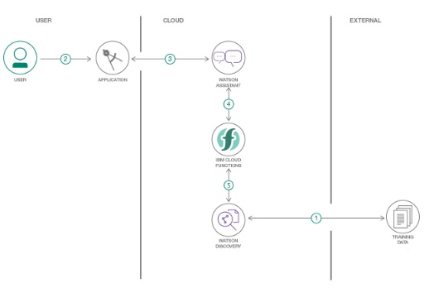

**3.2 Hardware / Software Designing**

1. Create necessary Watson Services.

2. Configure Watson Discovery.

3. Create Watson Cloud Functions Action.

4. Configure Watson Assistant.

5. Integrate Watson Discovery with Watson Assistant using webhook.

6. Build Node-RED flow to integrate Watson Assistant and Web Dashboard.

**4. Snapshots**

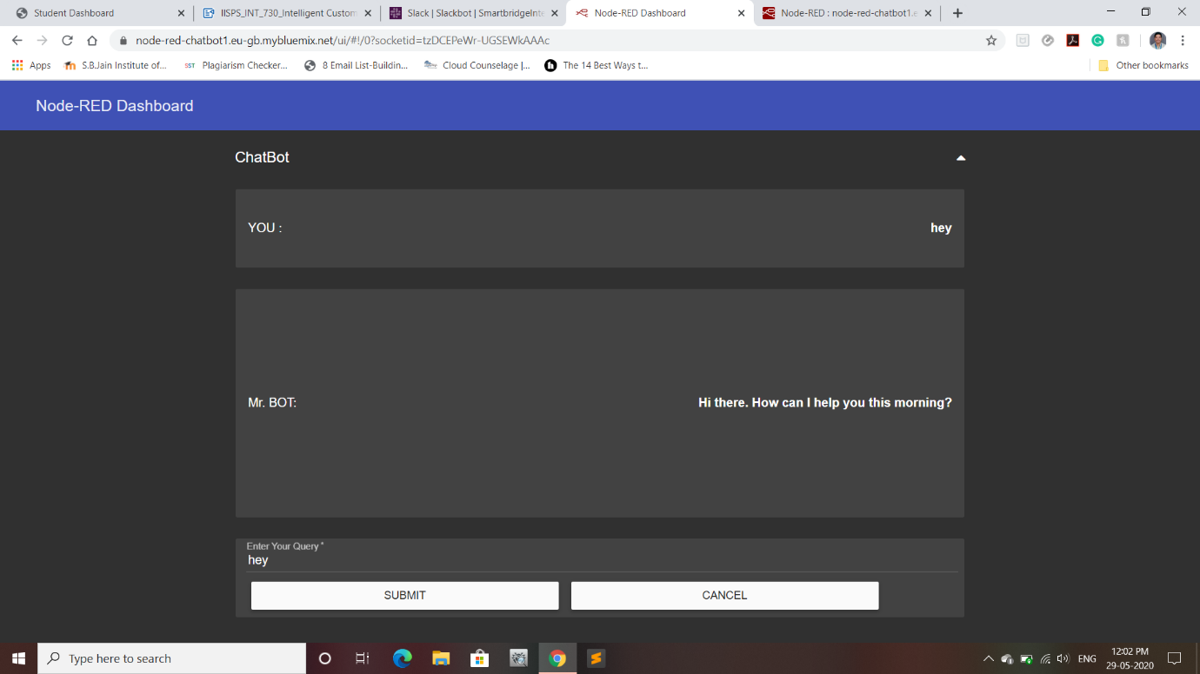

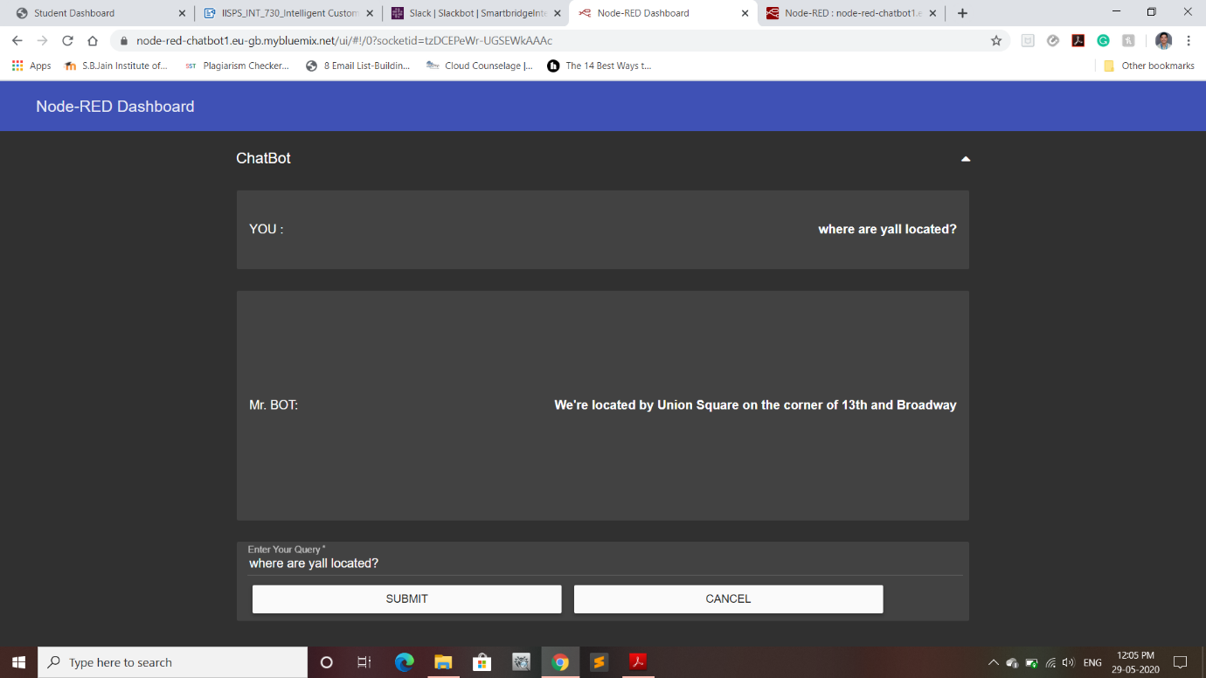

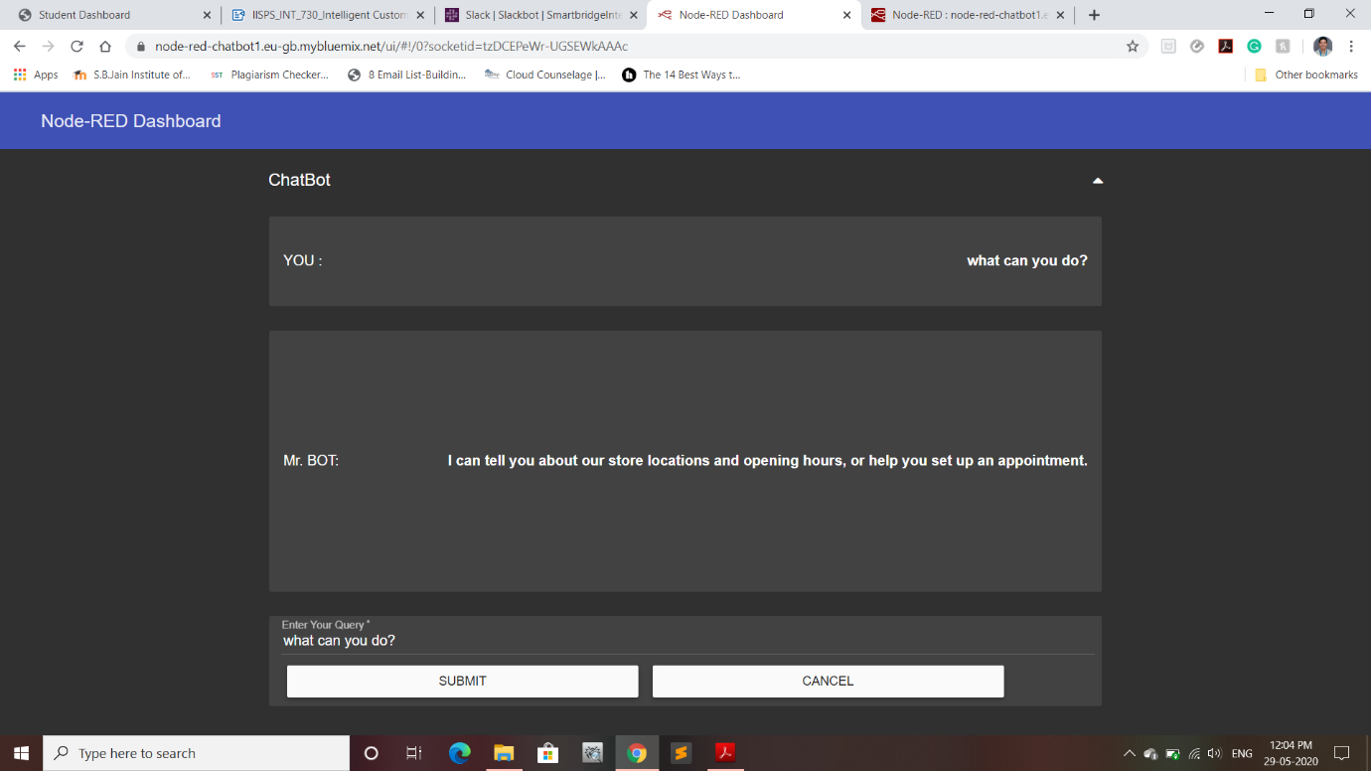

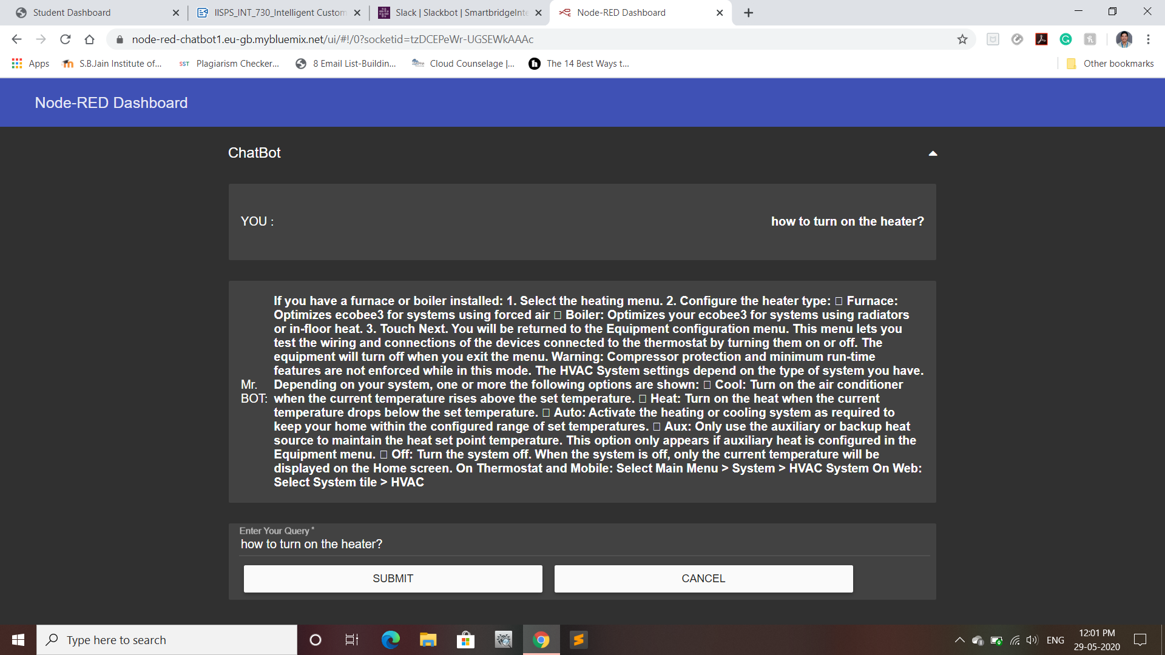

**5. Node-Red Flowchart**

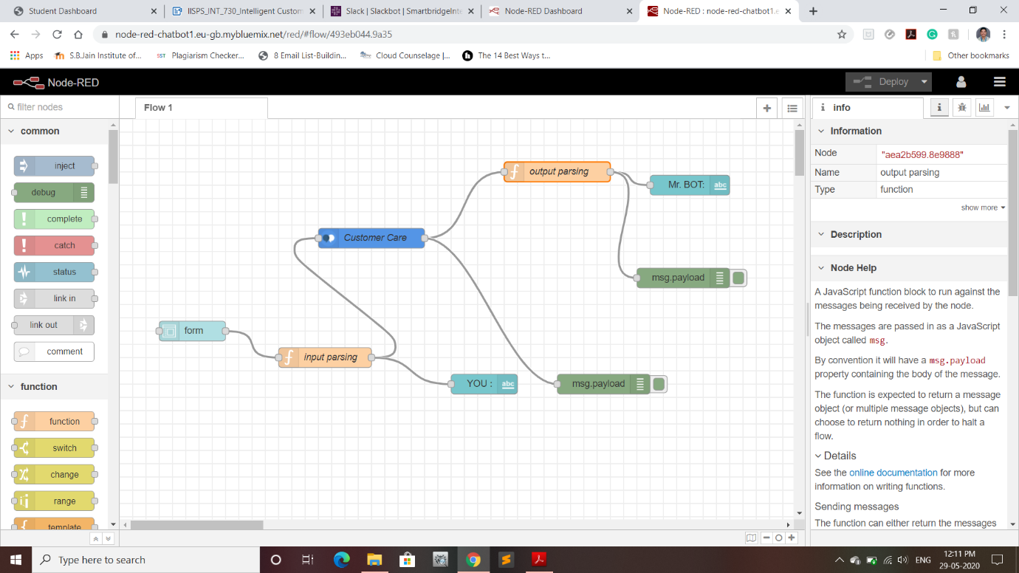

**6. Results**

Web based UI was developed by integrating all the services using

Node-RED.

URL for UI Dashboard: <https://node-red-chatbot1.eu-gb.mybluemix.net/ui/>

**7. Conclusion**

An Intelligent Customer Helpdesk Chatbot was created using various Watson

services like Watson Discovery, Watson Assistant, Watson Cloud Functions and

Node-RED.

**8. Future Scope**

In the future, various other Watson services like Text-To-Speech and Speech-To-Text can be integrated in the chatbot. This can make the chatbot Hands-free.

**9. Bibliography**

1. Node-RED Starter Application:

<https://developer.ibm.com/tutorials/how-to-create-a-node-red-starter-application/>

2. Build your own AI assistant:

<https://www.youtube.com/watch?v=hitUOFNne14>

3. How to use Watson Assistant with Webhooks:

<https://www.youtube.com/embed/5z3i5IsBVnk>

4. Watson Discovery:

<https://developer.ibm.com/articles/introduction-watson-discovery/>